**PRESENTATION REPORT**

Artificial Intelligence (INT-404) Project

On

**ERROR DETECTION AND PREVENTION IN FINANCE**

Submitted by

***Ayush Gupta 12105138***

***Ranga Sriya 12101402***

***Sameer Ahmed Qureshi 12019314***

In partial fulfilment for the requirements of the award of the degree of

***Bachelor of Technology***

***(Computer Science and Engineering)***



Submitted to

Lovely Professional University

Phagwara, Punjab

# Introduction

The Financial Services Industry has entered the Artificial Intelligence (AI) phase of the digital marathon, a journey that started with the advent of the internet and has taken organisations through several stages of digitalisation.

Artificial Intelligence (AI) is increasingly being used in finance to help detect and prevent errors, fraud, and other types of financial crime.

Artificial intelligence (AI) and machine learning in finance encompasses everything from chatbot assistants to fraud detection and task automation. Most banks (80%) are highly aware of the potential benefits presented by AI, according to Insider Intelligence’s AI in Banking report.

The decision for financial institutions (FIs) to adopt AI will be accelerated by technological advancement, increased user acceptance, and shifting regulatory frameworks. Banks using AI can streamline tedious processes and vastly improve the customer experience by offering 24/7 access to their accounts and financial advice services.

# Types of Fraud in Finance:

Fraud in finance can be classified into two categories:

1.Internal Fraud 2. External Fraud

Internal fraud occurs when an employee of the financial institution engages in fraudulent activities, while external fraud is committed by outsiders, such as hackers or scammers.

Some common types of financial fraud include:

1. Credit Card Fraud 3. Money Laundering

2. Identity Theft 4. Cyber Fraud

# Impacts Of AI in Fraud Detection

The impact of AI in finance as fraud detection is substantial and can lead to several benefits for financial institutions, businesses, and consumers. Here are some key impacts of AI in finance as fraud detection

* Improved Accuracy
* Increased Efficiency
* Proactive Detection
* Reduced Cost
* Improved Customer Experience
* Enhanced Security
* Compliance with Regulations

# How AI can Help Detect Fraud

Error detection in finance by credit card typically involves identifying and resolving any discrepancies or issues that arise in credit card transactions, i.e., fraudulent transactions, incorrect charges, double charges, and other errors that may impact the accuracy of the cardholder's billing statement.

AI can help detect fraudulent activities in several ways.

* One of the primary methods is through the use of machine learning algorithms that analyze large amounts of data to identify patterns and anomalies. AI can also be used to monitor transactions in real-time, which can help detect suspicious activities before they become more significant problems.
* Another approach is to use natural language processing (NLP) to analyze text data, such as emails or chat messages. NLP can identify patterns in language that may indicate fraudulent activities, such as the use of specific words or phrases.
* AI can also be used to detect fraud by analyzing user behaviour. By creating a user profile and monitoring their behaviour, AI can identify unusual activities and alert the financial institution to investigate further.
* Finally, AI can be used to identify fraudulent images or documents. Image recognition technology can detect if an image has been tampered with, while document analysis can identify if a document has been forged or altered.

Advantages

The benefits of using AI for fraud detection in finance are numerous.

* By automating the detection process, financial institutions can save time and money while also improving accuracy.
* AI can quickly identify fraudulent activity, allowing institutions to take action to prevent financial losses and protect their customers.
* Additionally, AI can be used to predict potential fraud before it occurs, enabling institutions to take proactive measures to prevent it.
* Overall, AI has the potential to revolutionize fraud detection in finance, making it faster, more accurate, and more effective.

# Challenges and Limitations

* One significant challenge is the quality and quantity of data. AI requires large amounts of high-quality data to work effectively, which may not always be available in fraud detection.
* Another challenge is the potential for bias in AI algorithms. AI can only be as objective as the data it is trained on, and if the data is biased, the algorithm may produce biased results.
* Finally, AI is not a replacement for human judgment. While AI can help detect fraudulent activities, it still requires human intervention to investigate and confirm the findings.

# Applications Of AI in Fraud Detection in Finance

* Transaction Monitoring
* Customer Behaviour Analytics
* Natural Language Processing
* Fraud Prediction
* Network Analysis
* Biometric Authentication
* Chatbots

# Case Study

* **Credit Card Fraud and Who Become Targets Of Scams**

According to the FBI, credit card fraud is “the unauthorized use of a credit or debit card, or similar payment tool to fraudulently obtain money or property.”

All players involved in the card-based payment process can potentially fall victim to scammers, including:

* Cardholders,
* Online merchants,
* Payment processing companies,
* Credit card payment systems,
* Card issuers (issuing banks), and
* Acquirers (acquiring banks)

The Future of AI in Fraud Detection

AI has the potential to revolutionize fraud detection processes in the future. With advancements in the technology, AI can provide near-instantaneous fraud detection and prevention, allowing banks to identify and block fraudulent activities early on. AI-enabled has the potential to significantly reduce financial losses caused by fraudulent activities.

# Screenshots of Code





# 

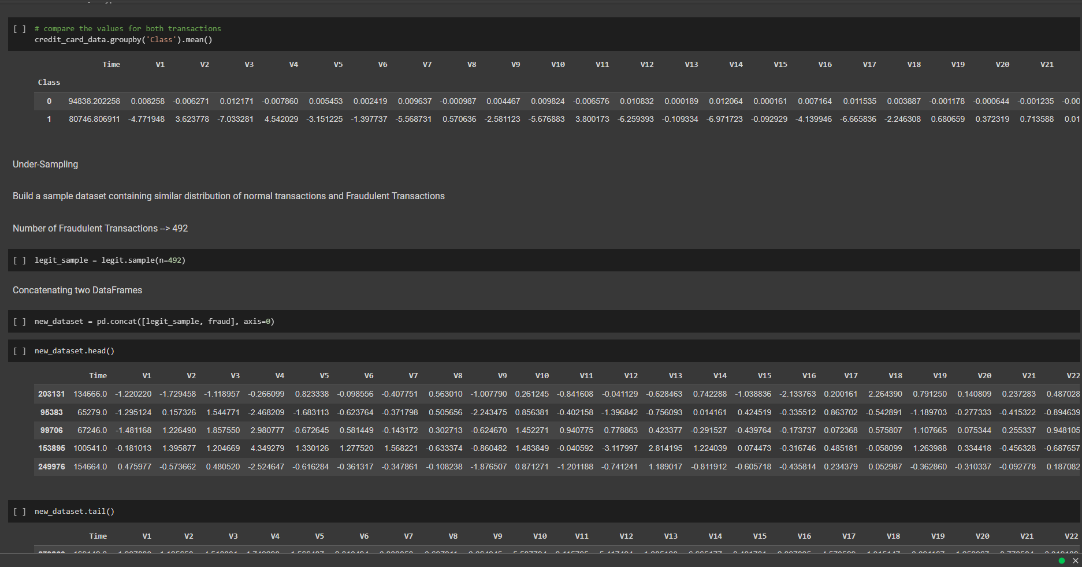



# Conclusion

However, AI is not a replacement for human judgment, and financial institutions should still rely on their employees to investigate and confirm any suspicious activities identified by AI.

AI-powered fraud detection systems can improve accuracy, increase efficiency, reduce cost, and enhance security, improving the customer experience and helping financial institutions comply with regulations related to fraud detection and prevention.

Additionally, AI can predict potential fraud before it occurs by analyzing data from various sources, such as social media and public records.

Overall, the use of AI in finance as fraud detection is a promising development that has the potential to significantly improve the security and efficiency of financial transactions, while also reducing the risk of financial losses for financial institutions and consumers alike.